Question 1

Question 1 A
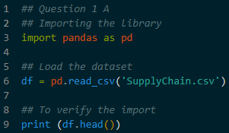
- The script used the pandas library to load the SupplyChain.csv file
- Purposes, to bring the raw data into a structured format (a DataFrame) so that python can manipulate it
- The df.head() function is used to display the first five rows, ensuring the columns (OrderID, Category, ShippingCost, etc) loaded correctly

Question 1 B
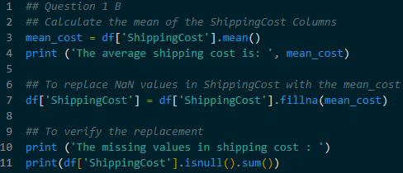
- The script calculates the mean(average) of the ShippingCost column and fills any NaN (Not a Number) entries with this value
- Using the mean is a common statistical method to handle missing numerical data without deleting entire rows, which helps maintain the dataset size for analysis

Question 1 C
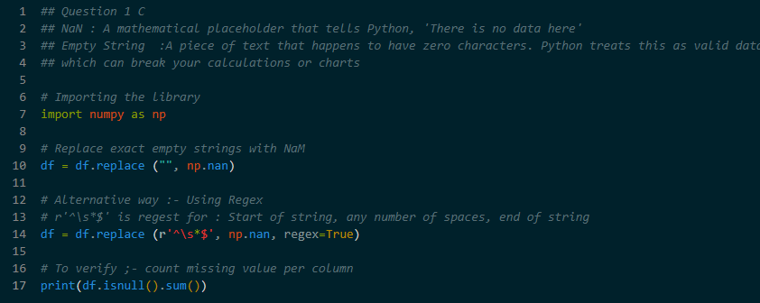
- The scripts identifies empty strings or strings containing only whitespace and converts them to NaN
- It uses Regular Expression (Regex) (r’^\S*$’) to find these invisible characters
- In many datasets, ‘missing’ data is entered as blank space. Python treats a blank space as a valid piece of text, which can cause errors during math operation.
- Converting them to NaN ensures they are recognized as truly missing

Question 1 D
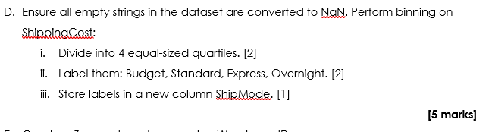
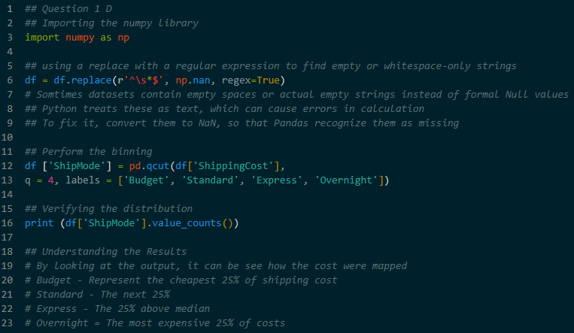
- Data Binning (Categorization)
- The continuous ShippingCost data is divided into four equal-sized groups (quartiles)
- Using pd.qcut() the script assigns labels – Budget, Standard, Express, Overnight – to these groups and saves them in a new column named ShipMode
- This transforms a specifc dollar amount into category, making it easier to compare shipping tiers

Question 1 E
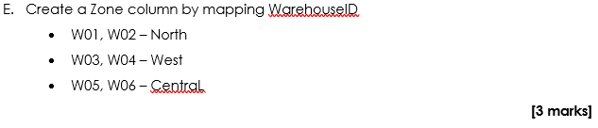
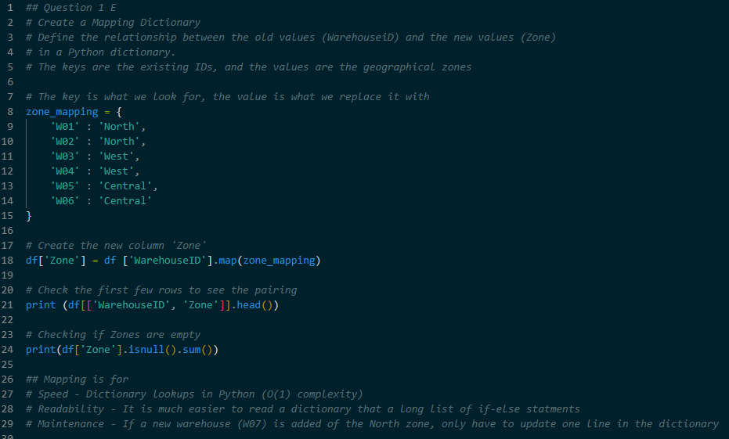
- A new Zone column is created by grouping specifc WarehouseID values together
- Mapping Logic
  - North : W01, W02
  - South : W03, W04
  - Central : W05, W06
- For efficiency – the script uses Python Dictionary and the .map() function. It is faster to execute and easier to update than multiple if-else statements

Question 1 F
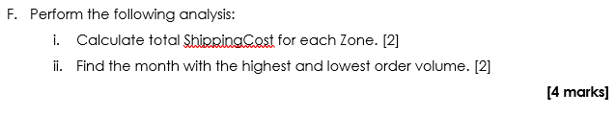
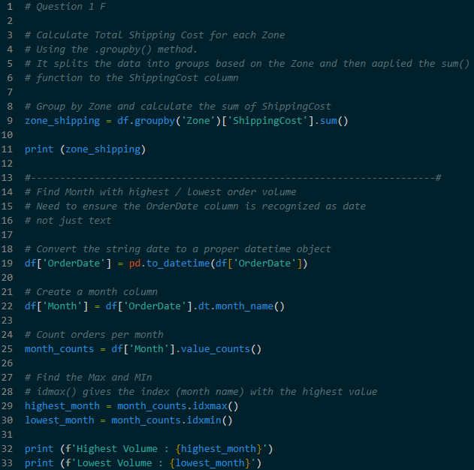
- Total Cost By Zone : The script uses .groupby(‘Zone’) to aggregate the total shipping expenses for each geographical area
- The OrderDate column is converted from a string text to a datetime object
- The script extracts the month name from the dates
- Identifies which months had the highest and lowest number of orders using idxmax() and idxmin()

Summaries
Task | Pandas Method Used | Result
Data Cleaning | .fillna(mean) | Replaces missing numbers with the average.
Standardization | .replace(regex=True) | Converts empty text/spaces to null values.
Classification | pd.qcut() | Groups costs into 4 ranked shipping modes.
Data Joining | .map() | Links Warehouse IDs to specific Zones.
Aggregation | .groupby().sum() | Calculates total costs per region.
Time Analysis | pd.to_datetime() | Allows Python to understand and sort dates.

